**Hotel Management System**

**Submitted by**

Anusha Kokkinti- 01856785

Neeharika Gopala- 01834758

Sultan Alasfour- 01789817

**OMIS 651 – Systems Analysis and Design**

Northern Illinois University

Instructor: Dr. Onkar S. Malgonde

Spring 2019

**Table of Contents**

Executive Summary 3

As-Is System 3

Five-Factor Model 3

Requirement Specification Techniques 3

Use Cases 3

*Feedback system* 3

*Online reservation system* 3

Use case3 3

Use case 4 3

Use case 5 3

Hotel Management System

**Executive Summary**

Hotel is a highly-profitable business as it provides temporary accommodation to various categories of people like travelers, tourists, pilgrims, business people etc. To manage and maintain such a huge and ever blooming business, there is a need for an effective hotel management system involving multiple marketing strategies to keep up its competition in the business. The market standing of a business is directly influenced by its management.

The incapability to embrace an effective Hotel Management System might lead to the failure of hotel to achieve its targets. Using a fine-tuned software for a hotel business saves both time and effort, enables a hotel to become dominant in business, and promotes the retention of the existing customers while attracting new customers. Changing times lead to changing demands. There are many challenges and issues to be faced by the current management system as per the changing technologies and customers’ behavior. The main focus of this report will be to develop an effective hotel management system that will overcome the challenges in marketing faced by the current system. This will be important in improving the customer base and profitability of the hotel.

**As-Is System**

Most of the hotels to date doesn’t have an optimized website. It is not appropriate for a hotel to have a website and expect to get direct bookings. The modern world has changed rapidly with technology and competition is growing rapidly across different channels. It’s very important to have an optimized website for all devices. A hotel website with too many exits links to other sites, not rewarding their customers with upgrades or membership points results in a decline of performance of the entire hotel and affects its revenue. The current system has the following problems:

1. The hotel has a website without any reservation link to book rooms online instantly. The customer has to call or send an email to the hotel reservation desk asking about the vacancy of rooms then hotel staff responds accordingly with all details. This is causing a lot of delay and loss to the hotel. In the midst of vacations, long weekends etc. Hotel is receiving lots of requests from customers over call and email about the vacancies and it is getting to be troublesome for the staff to respond within no time and keep a track of all bookings made.
2. The current hotel management system doesn’t have any customer feedback system for collecting feedbacks after the customer’s stay and there is no email engagement pre and post stay.
3. It is progressively important to have an intrinsic awareness of your data and to continue to focus energy on marketing which gives you positive results. The current system is not updated regularly as per the demand in the market. It doesn’t offer any special deals or redeem points in order to attract customers and provide them quality service.

Hence Hotel Management System needs the introduction of Agile methodology where different marketing and pricing strategies are incorporated at every step of development to accomplish necessary results.

**Five-Factor Model**

***The Five Critical Factors Influence:***

***Size-*** In the existing system, the hotel management still follows the old plant driven methodologies, due to which the system is fragmented into multiple departments like reservation, sales, Information, logistics etc. As the departments increases, the size of teams, requisites & efforts to manage this data also increases.

***Criticality***- The criticality of the project is high as the hotel management operations like room reservations, rooms assignment, price variations, transactions and feedback system should be highly monitored and are to carry out in swift & secure manner. Any disruptions to the system will have markable impact on the hotel’s revenue.

***Dynamism-***The customers are becoming more tech-savvy and are allured towards the changing technologies. So, to sustain its retaining customers and to attract new potentials, there is high need to keep up with the current trends and dynamic technologies.

***Personnel-*** As the level of dynamism increases in this industry, there is need for a proficient & diverse teams to meet the customer expectations, market trends, technologies and other operational challenges.

***Culture-*** In this industry, culture is of utmost importance. It is all about the values that defines the service-oriented organization. Satisfied and dedicated personnel reflect the returning customers thereby increasing revenue.

**Requirement Specification Techniques**

**Interviews**

With the development of the hotel management system, there is need to ensure that all the stakeholders understand the requirements of the system and whether they are compatible with the system. As such, interview will be used as the requirement elicitation technique. Interviews will be conducted one-on-one with the participants.

1. ***Selecting interviewees***

The participants to be included in the interview include the marketing team, marketing manager, front office team, and accounts manager. These participants will be interviewed about the specific requirements that would like included in the new system.

1. ***Designing interview questions***

Semi-structured questions will be used to conduct the interviews. This will be important in directing the interview specifically to marketing strategies while ensuring that much information is obtained from the participants.

1. ***Preparation for interview***

**Interview plan** – an interview plan highlighting the areas and topic to be covered will be developed. The areas in which the interviewees are knowledgeable about will be identified.

1. ***Conducting the interview***

Inform participants – all the participants will be informed about the reasons for conducting the interview and will be asked to provide all the necessary information to help improve the hotel management system.

1. ***Post-interview follow-up***

This will be conducted mainly by the technical experts who will interpret all the information provided by the interviewees. The key areas to be addressed as identified from the interviews will be taken into consideration in improving the system. In case the technical experts are faced with challenges in interpreting the information, they will go back to the interviewees for clarification. Finally, the technical team will be prepare a report based on the obtained information. This report will be forwarded to the software development team for implementation.

**Use Cases**

Our report identified five key use cases that include; feedback system, online reservation system, Cancel Reservation, Upgrade Reservation and Login.

|  |  |  |  |  |
| --- | --- | --- | --- | --- |
| **Use Case Name:** Feedback System | | | **ID:** G5-001 **Priority:** High | |
| **Actor:** Customer, Marketing team | | | | |
| **Description:** When checking out of the hotel, the client is required to complete a section on customer feedback. | | | | |
| **Trigger:** The marketing department needs customer feedback to improve on service delivery at the hotel.  **Type:** External | | | | |
| **Preconditions:** | | | | |
| **Normal Course:**   1. The client checks out of the room. 2. During checkout, the client is required to complete a form indicating their experience at the hotel. 3. The feedback is categorized into different sections that are relevant to the hotel. 4. The marketing team act on the feedback by sharing with the relevant departments which are responsible for implementing changes. 5. The marketing department follow-up with the clients who gave feedback to address their concerns. | | | **Information for Steps:**   1. Client checks out. 2. Complete a form on customer experience 3. Feedback is categorized 4. Action on the feedback 5. Follow-up with the customers | |
| **Alternative Course:**   1. The receptionist asks for customer ID and email address 2. Customer ID and email address are entered into the system. 3. The system confirms the customer’s information and status. 4. A website survey is sent to the customer to provide feedback at any convenient time. 5. The marketing team act on the feedback. 6. Follow-up is carried out on the clients who responded to the online survey. | | | 1. Request customer ID and email address 2. Enter customer ID and email address 3. Confirmation of customer information 4. Send website survey 5. Act on feedback 6. Follow-up with clients | |
| **Postconditions:** The customer is expected to provide feedback by completing a feedback form in the system.  The marketing team receives the feedback and take the necessary measures | | | | |
| **Exceptions:** | | | | |
| **Summary Inputs** | **Source** | **Outputs** | | **Destination** |
| Customer ID, Email address | Customer | Customer feedback | | The marketing team receives the feedback and acts on it |

|  |  |  |  |
| --- | --- | --- | --- |
| **Use Case Name:** Online reservation system | | **ID:** G5-002 **Priority:** High | |
| **Actor:** Customer, Marketing department, Accounting department | | | |
| **Description:** The customer in need of a hotel room will make inquiries about the availability of a rooms and make a reservation | | | |
| **Trigger:** Need for a room at the hotel  **Type:** External | | | |
| **Preconditions: -** Customer needs to meet minimum age requirements | | | |
| **Normal Course:**   1. The customer logs in to the online reservation system. 2. Enters personal information including Full names, Gender, Age, Email address, Phone number and Mode of payment. 3. The system generates client data 4. The client is requested to make partial payment 5. Notification sent to the client about status of booking | | **Information for Steps:**   1. Customer log in to the system 2. Enter personal information 3. Generate client data 4. Request for partial payment 5. Send notification | |
| **Alternative Course:**   1. The customer makes contact with the marketing team. 2. The marketing team asks for client details including Full names, Gender, Age, Email address, Phone number and Mode of payment 3. The data is entered in the reservation system 4. The system generates client data 5. The client is requested to make partial payment 6. The client is allocated a room. | | 1. Customer makes contact 2. Request customer information 3. Enter customer data 4. System generates data 5. Request for partial payment 6. Allocation of room | |
| **Postconditions:** The marketing department will confirm the booking status of the customer in the online reservation system.  The customer is allocated a room.  The customer pays the amount for the room prior to arrival at the hotel. | | | |
| **Exceptions:** | | | |
| **Summary Inputs** | **Source** | **Outputs** | **Destination** |
| Customer ID, First name, Last name, Gender, Age, Email, Phone number | Customer | Confirmation of customer | Reception,  Marketing department,  Accounting department |

|  |  |  |  |
| --- | --- | --- | --- |
| **Use Case Name:** Cancel Reservation | | **ID:** G5-003 **Priority:** High | |
| **Actor:** Customer, Receptionist | | | |
| **Description:** The customer wants to cancel the reserved room | | | |
| **Trigger:** Cancel a room reservation at the hotel  **Type:** External | | | |
| **Preconditions: -** Customer should have made a reservation prior to cancel | | | |
| **Normal Course:**   1. The customer logs in to the online reservation system. 2. Customer chooses option for cancellation 3. Enters the reservation ID as requested in the cancellation form 4. System generates the reservation details 5. System asks for confirmation to cancel and displays applicable charges 6. The user confirms cancellation and makes payment 7. System generates the confirmation message of cancellation | | Information for Steps:   1. Customer log in to the system 2. Customer searches for the cancellation form 3. Customer provides reservation details 4. System displays the relevant details 5. Approval for cancellation 6. Confirmation of Cancellation 7. System displays successful cancellation message | |
| **Alternative Course:**   1. Customer contacts the front desk representative 2. Receptionist asks for reservation details 3. Data is entered into the system 4. The system generates the customer data 5. Client is requested to pay cancellation charges if needed 6. User confirms cancellation and payment is made 7. Receptionist confirms cancellation and system generates the confirmation message of cancellation | | 1. Customer communicates with the receptionist 2. Request customer information 3. Enter customer data 4. System generates data 5. Request for payment 6. Confirmation of cancellation 7. Customer receives confirmation | |
| **Postconditions:** The reservation department will confirm the cancellation status of the customer in the online reservation system.  The room will be available for booking. | | | |
| **Exceptions:** | | | |
| **Summary Inputs** | **Source** | **Outputs** | **Destination** |
| Customer ID, First name, Last name, Reservation ID, Email, Phone number | Customer | Confirmation of cancellation request | Reception,  Reservation department |

|  |  |  |  |
| --- | --- | --- | --- |
| **Use Case Name:** Upgrade Reservation | | **ID:** G5-004 **Priority:** High | |
| **Actor:** Customer, Receptionist | | | |
| **Description:** The customer wants to upgrade the reserved room | | | |
| **Trigger:** Upgrade a room reservation  **Type:** External | | | |
| **Preconditions: -** Customer should have made a reservation prior to upgrade | | | |
| **Normal Course:**   1. The customer logs in to the online reservation system. 2. Customer chooses option for upgradation 3. Enters the reservation ID as requested in the upgradation process 4. System generates the reservation details and displays the available upgrade options 5. System asks for confirmation to upgrade and displays applicable charges 6. The user confirms the upgrade and makes payment 7. System generates the confirmation message of upgradation | | Information for Steps:   1. Customer log in to the system 2. Customer searches for the upgradation option 3. Customer provides reservation details 4. System displays the available room   details.   1. System asks for the confirmation 2. Confirmation of upgradation 3. System displays successful upgrade message | |
| **Alternative Course:**   1. Customer contacts the front desk representative 2. Receptionist asks for reservation details 3. Data is entered into the system 4. The system generates the reservation data and the representative checks the available options for upgrade. 5. Client is requested to pay upgrade charges 6. User confirms upgradation and payment is made 7. Receptionist confirms upgradation and system generates the confirmation message of upgradation | | 1. Customer communicates with the receptionist 2. Request customer information 3. Enter customer data 4. System displays requested data 5. Request for payment 6. Confirmation of upgradation 7. Customer receives confirmation | |
| **Postconditions:** The reservation department will confirm the upgradation status of the customer in the online reservation system.  The room will be available for booking. | | | |
| **Exceptions:** | | | |
| **Summary Inputs** | **Source** | **Outputs** | **Destination** |
| Customer ID, First name, Last name, Reservation ID, Email, Phone number | Customer | Confirmation of upgradation request | Reception,  Reservation department |

|  |  |  |  |
| --- | --- | --- | --- |
| **Use Case Name: Conference Room Booking** | | **ID:** G5-005 **Priority:** Medium | |
| **Actor:** Customer | | | |
| **Description:** The customer wants to login to the website to book a conference room | | | |
| **Trigger:** Access the website  **Type:** External | | | |
| **Preconditions: -** Customer should have made a registration prior to login | | | |
| **Normal Course:**   1. The user logins to Online reservation System and click on the option for Conference room booking 2. The system asks for the number of people, date and time 3. User provides the requested details and click on Search button. 4. The system shows the availability of the rooms. 5. User selects a room and proceed for payment. 6. System asks for confirmation and displays applicable charges 7. The user confirms booking and makes payment 8. System generates the confirmation message & details of booking. | | Information for Steps:  1.User access the reservation portal to book a  conference room  2. System requests the necessary information for  Booking  3. User provides the details  4.System displays the available rooms for the  provided date and time  5.User is asked to select the desired room  6.System asks for the confirmation    7.User makes the payment  8.System displays the booking confirmation | |
| **Alternative Course:**   1. The user logins to Online reservation System and click on the option for Conference room booking 2. The system asks for the number of people, date and time 3. User provides the requested details and click on Search button. 4. The system shows the unavailability of the rooms and asks for the re-adjustment of date and time fields 5. User re-adjust the dates and checks for the availability 6. The system shows the availability of the rooms. 7. User selects a room and proceed for payment. 8. System asks for confirmation and displays applicable charges 9. The user confirms booking and makes payment 10. System generates the confirmation message & details of booking. | | 1.User access the reservation portal to book a  conference room  2. System requests the necessary information for  Booking  3. User provides the details  4. System displays the unavailability and ask to  adjust the search options    5.User refines the search options  6.System displays the available rooms for the  provided date and time  7.User is asked to select the desired room  8.System asks for the confirmation      9.User makes the payment  10.System displays the booking confirmation | |
| **Postconditions:** User performs necessary actions after login  . | | | |
| **Exceptions:** | | | |
| **Summary Inputs** | **Source** | **Outputs** | **Destination** |
| No of people, date & time | Customer | Booking confirmation | Conference room confirmation Details |

**UML Diagram**

The system is based on assumptions:

ANS Group of hotels is an international chain of hotels which introduces an online reservation system with advanced reporting, tracking and revenue decision making applications. There are two types of employees involved in the system and they are receptionists and Marketing team. The receptionist takes of the multiple administrative operations and helps the customers to fix any issues while making the reservations. The ANS Marketing team are involved in tracking & reporting applications of the reservation system while accessing the multiple feedbacks from the customers to make the enhanced business decisions.

A customer of ANS hotels can be new or registered customer. The new customer undergoes the process of registration where they must give their name, address, contact and age details. Once the customer is registered, they are provided with the unique customer ID to track their returning frequency and to classify the customers to make decisions on discounts and other promotional activities. A customer can make, cancel and upgrade the reservations at any time as the website is made available all the time. If the customer chooses to make the reservation, he will be asked for the check -in, check-out, type of room, range of the room and guest information. Once the customer provides the required details, he/she will be taken to the available rooms page. Then the customer selects the rooms and will proceed through the payment portal. The system provides the two types of payment options via card or wallet. Once the payment is completed, customer is provided with a unique reservation ID to track/cancel/upgrade the reservation.

By introducing the online reservation system, the company gains the multiple advantages such as 24/7 availability of website allowing to maximize the sales & increased customers, effective management of booking system making the employees to concentrate on other critical issues to enhance business, provides the valuable insights to the business decision making, making the payments faster & safer and contributing towards the effective management of the information.

**Actors involved and their operations:**

1. Receptionist: Receives the bookings through customer portal and processes it. Also assists in administrative operations.
2. Customer: Registers in the hotel website and can make a reservation/upgrade/cancel and makes payment for the reservation. Also provides feedback about the services/issues.
3. Marketing Team: Analyses and generates reports of feedbacks received from different feedback systems like Maintenance, Food facilities and Customer service.

**Use Cases:**

* Registration
* Book a reservation
  + Rooms
  + Conference halls
* Cancel Reservation
* Upgrade Reservation
* Feedback
  + Maintenance
  + Food facilities
  + Customer Service
* Make payment
  + Cash
  + E-Wallet

**User Interface Screens**

Welcome Page:

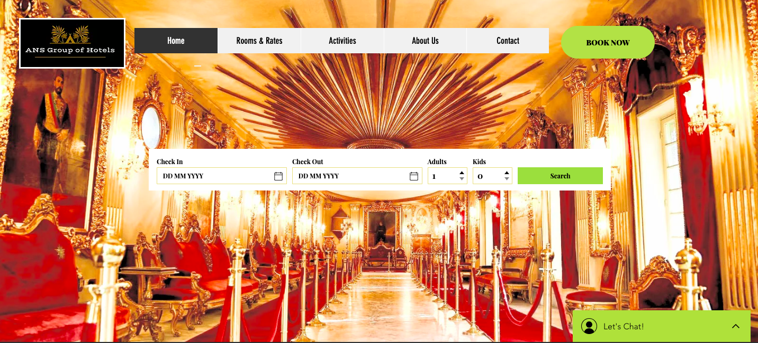

Display of details

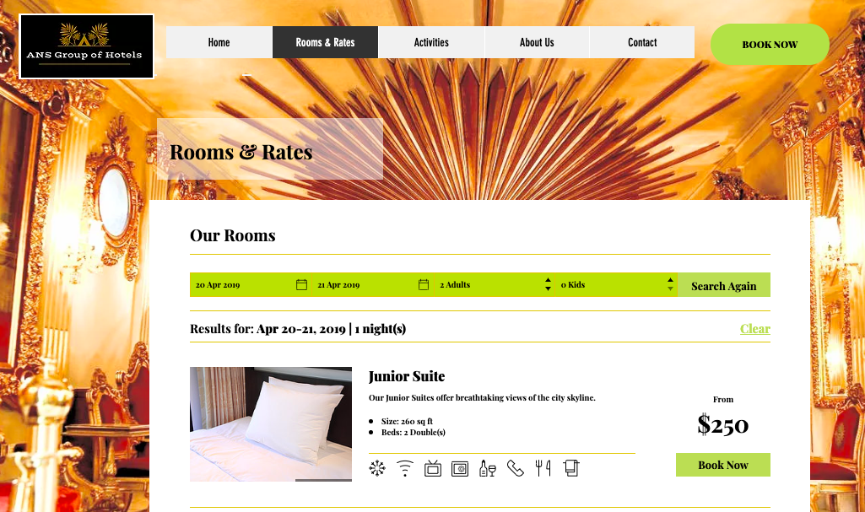

Booking Confirmation:

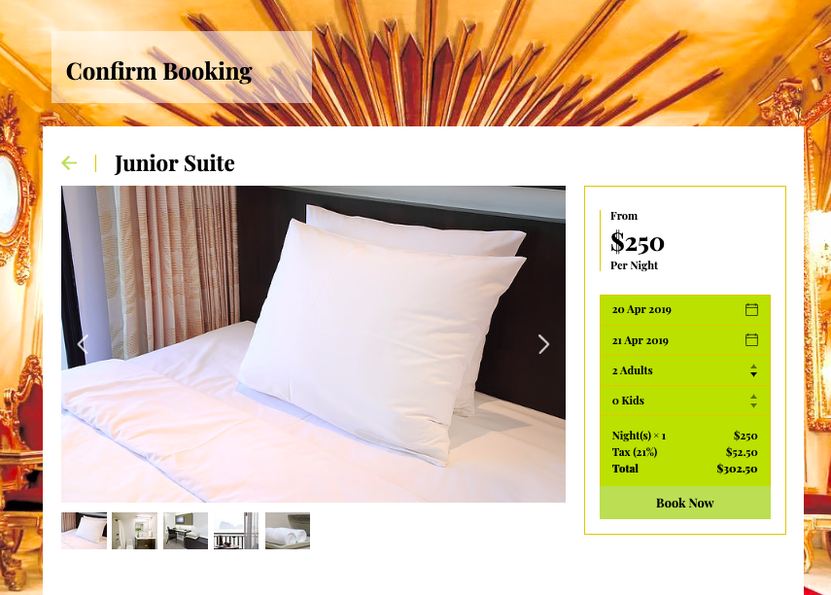

Payment Gateway: 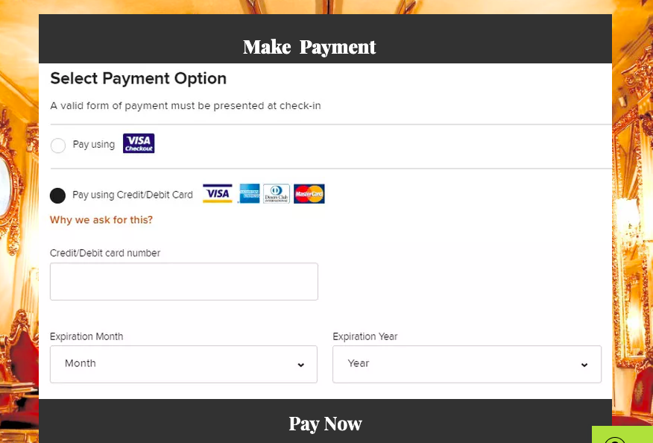

Confirmed Booking acknowledgement:

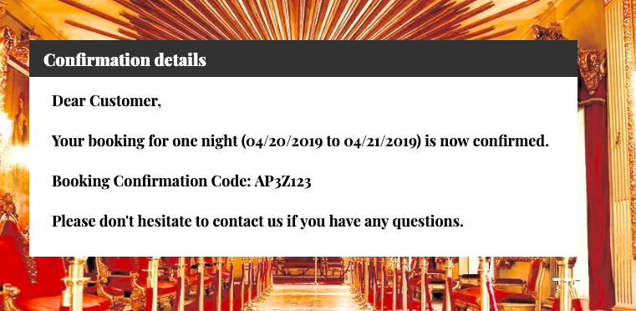

**Software Acquisition Strategy and Architecture**

**Packaged Software:**

For the Online reservation system, we have considered the packaged software acquisition strategy (Cloudbeds) as it allows us to reduce manual efforts, maximize employee efficiency, remain competitive, become more prolific and efficient.

The platform effectively simplifies tasks such as online reservation management, room assignment, amenities booking and other administrative operations. It seamlessly integrates with third-party applications such as CRM and digital marketing tools, enabling the management to focus on making enhanced business decision making by letting go of manual efforts of integration workflows. Apart from these, Cloudbeds can effectively manage the hotels overall working system taking their businesses to the top level.

Advantages:

1.**Improved Efficiency**: When the individual components of a software platform are integrated, fully tested and are built into a single software, they serve all the primary applications and reduce the cost of building the entire software from the scratch and thereby improving efficiency and the overall user experience

2.**Improved Productivity**: Packaged software will have regular updates; enhancements and the providers ensure that the software is up-to date thereby enhanced productivity of the work being performed without any barriers.

**Cloud Computing:**

A Cloud based hotel booking system can provide management with a host of benefits. It allows the management of reservation system with great ease and carry out the multiple tasks simultaneously.

* It enables the real time distribution by instantly updating the bookings and rate across all the channels.
* It simplifies the booking process, reduce the errors and ensures that there are no double or overbooking issues.
* It allows the automatic sync of data into a centralized system for faster access and easy management of data in real time.

**Test Cases**

|  |  |
| --- | --- |
| **Test Case ID** | **TSC01** |
| Component | Book Reservation |
| Purpose of Test Case | To enable a customer to make reservation |
| Functional Test Type | Integration Test |
| Pre-Conditions | The check-in page should be displayed correctly. The customer log in buttons should be clicked. The text boxes for personal information and mode of payment should be active. |
| Inputs | Valid client personal information |
| Expected Outputs | The client logins and ID are accepted as input and the system tells whether the Customer’s ID is valid or not. |
| Post-Conditions | The client process to be allocated a room |
| Execution History | |  |  |  | | --- | --- | --- | | **Date** | **Result** | **Tester** | | 02/15/19 | Passed | Neeharika Gopala | |

|  |  |
| --- | --- |
| **Test Case ID** | **TSC02** |
| Component | Customer identification |
| Purpose of Test Case | To ensure that customer ID is recognized and accepted in the system |
| Functional Test Type | Integration Test |
| Pre-Conditions | The check-out page should be displayed correctly. The Enter Customer ID text box should be active. |
| Inputs | Valid customer ID |
| Expected Outputs | The customer ID should be accepted with the system indicating whether the customer’s ID already exists and is valid. |
| Post-Conditions | The customer proceeds to check out. |
| Execution History | |  |  |  | | --- | --- | --- | | **Date** | **Result** | **Tester** | | 02/20/19 | Passed | Neeharika Gopala | |  |  |  | |  |  |  | |

|  |  |
| --- | --- |
| **Test Case ID** | **TSC03** |
| Component | Payment management |
| Purpose of Test Case | To validate and process payment made by a customer |
| Functional Test Type | Integration Test |
| Pre-Conditions | The hotel room charges, meals, and other additional costs accrued during stay at the hotel are calculated. The payment is indicated pending awaiting clearance by customer. |
| Inputs | Customer payment details |
| Expected Outputs | The customer payment details are accepted and payment request processed. |
| Post-Conditions | The payment receipt is generated and the customer proceeds to check out. |
| Execution History | |  |  |  | | --- | --- | --- | | **Date** | **Result** | **Tester** | | 02/20/19 | Passed | Sultan Alasfour | |  |  |  | |  |  |  | |

|  |  |
| --- | --- |
| **Test Case ID** | **TSC04** |
| Component | Update Reservation |
| Purpose of Test Case | To verify that the customer can select the reservation from existing reservation |
| Functional Test Type | Integration Test |
| Pre-Conditions | Reservation details should be displayed, and the customer clicks on the update button to invoke update reservation interface |
| Inputs | 1.Customer can make changes in the fields  2.Customer can cancel the upgrade form any time  3.Mandatory fields must be filled  4.Upon clicking update button, information should be updated |
| Expected Outputs | 1.System should allow users to make changes in the fields  2.System should cancel the form  3.System should check the fields and if empty generate the error message  4.System should update the form |
| Post-Conditions | The customer proceeds to check out. |
| Execution History | |  |  |  | | --- | --- | --- | | **Date** | **Result** | **Tester** | | 02/20/19 | Passed | Anusha Kokkinti | |  |  |  | |  |  |  | |

|  |  |
| --- | --- |
| **Test Case ID** | **TSC05** |
| Component | Booking Confirmation page |
| Purpose of Test Case | To verify that the booking details are being generated on booking confirmation page |
| Functional Test Type | Unit Test |
| Pre-Conditions | Customer should have made an active reservation |
| Inputs | 1.Launch the ANS Hotel website URL  2.Select the check-in, check-out, No of adults and children options  3.Select the available rooms for booking and click on confirm room booking  4.Make Payment |
| Expected Outputs | Booking Confirmation details should be displayed with the reservation ID and booking dates |
| Post-Conditions | The customer process to allocate the room |
| Execution History | |  |  |  | | --- | --- | --- | | **Date** | **Result** | **Tester** | | 02/20/19 | Passed | Anusha Kokkinti | |  |  |  | |  |  |  | |

**Test Plan**

|  |  |
| --- | --- |
| **Program ID** | AHMS |
| **Version Number** | FT-01 |
| **Date Designed** | 02/22/2019 |
| **Comments** | Rerun all the failed cases |
| **Tester** | ANS |
| **Execution History** | |  |  |  | | --- | --- | --- | | Interface ID | Data field | Result | | AD15436 | Reservation calendar is functional | Pass | | AD64297 | Customer enters valid username and password | Pass | | AD65274 | Page displaying online bookings is functional | Pass | | BX74163 | Check-in page indicates status of rooms as either reserved, occupied, or vacant | Pass | | BX43657 | Professional support tab is operational | Pass | | CT52832 | Selected rooms are highlighted | Pass | | DK12328 | Activities available can be highlighted | Pass | | EC32561 | Indicate successful submission of booking | Pass | |
| Expected Outputs | Customer personal information such as ID number and names should be accepted as input. The system should link the personal information to the room number where the customer stayed. |

**Transition style**

The transition to the new hotel management system is expected to contribute towards effective management of data and records in the hotel. The system will make it easy for clients to make reservation of rooms thus eliminate the tedious processes associated with the old system. A modular transition style will be employed, with each department shifting to the new system in modules or in stages, one after the other.

**Conclusion**

The hotel management system provides an effective means of enhancing the marketing strategies employed by the hotel. An effective hotel management system helps the hotel keep up with competition with other players in the industry. Further, a hotel management system is important in enabling the hotel to achieve its targets. The hotel management system proposed in this report is expected to make it easy for customers to make reservations for their rooms online. This will be convenient for clients and it will contribute in improving client base and profitability.